1.
A Project Report On

E-BOOK


<Project Title>

Submitted in partial fulfillment of the requirement for the award of the degree

Bachelor of Computer Application (BCA)

Academic Year 2025 – 26

<MOHYUDIN> <SAHIL> <SUDIPA>
<92300527154><92300527090><92300527262>

Internal Guide
(Hardik Chavda)



Rajkot-Morbi Road, At & PO : Gauridad, Rajkot 360 003. Gujarat. India.

Faculty of Computer Applications (FCA)


This is to certify that the project work entitled

E-BOOK
submitted in partial fulfillment of the requirement for the award of the degree of
Bachelor of Computer Application
of the

Marwadi University
is a result of the bonafide work carried out by

Sahil (92300527090)
Mohyudin (92300527154)

Sudipa (92300527262)

during the academic year 2025-26

Faculty Guide HOD Dean

DECLARATION

I/We hereby declare that this project work entitled E-BOOK is a record done by me.

I also declare that the matter embodied in this project is genuine work done by me and has not been submitted whether to this University or to any other University / Institute for the fulfillment of the requirement of any course of study.

Place :
Date :

SAHIL (92300527090) Signature :
MOHYUDIN (92300527154) Signature :
SUDIPA (92300527262) Signature :

ACKNOWLEDGEMENT

It is indeed a great pleasure to express our thanks and gratitude to all those who helped us. No serious and lasting achievement or success one can ever achieve without the help of friendly guidance and co-operation of so many people involved in the work.

We are very thankful to our guide Hardik Chavda, the person who makes us to follow the right steps during our project work. We express our deep sense of gratitude to for his /her guidance, suggestions and expertise at every stage. A part from that his/her valuable and expertise suggestion during documentation of our report indeed help us a lot.

Thanks to our friend and colleague who have been a source of inspiration and motivation that helped to us during our project work.

We are heartily thankful to the Dean of our department Dr. R. KHAN sir and HoD Dr. Sunil Bajeja sir for giving us an opportunity to work over this project and for their end-less and great support to all other people who directly or indirectly supported and help us to fulfil our task.

SAHIL (92300527090) Signature :
MOHYUDIN (92300527154) Signature :
SUDIPA (92300527262) Signature :

CONTENTS

Chapters | Particulars | Page No.
1 | SYNOPSIS
2  2.1  2.2 | PREAMBLE  General Introduction  Module description
3 | REVIEW OF LITERATURE
4  4.1  4.2 | TECHNICAL DESCRIPTION  Hardware Requirement  Software Requirement
5  5.1  5.2  5.2.1 5.3  5.3.1 5.3.2  5.3.3 5.4  5.4.1  5.4.2 | SYSTEM DESIGN AND DEVELOPMENT  Architectural Design  - Class Diagram  Dynamic Modeling  - Use Case Diagram  - Sequence Diagram  - Activity Diagram  - Any other applicable diagram (applicable)  Database Design (If applicable)  Relationship Diagram (ER)  Menu Design  Screen Design
6 | CONCLUSION
7 | LEARNING DURING PROJECT WORK
8  8.1  8.2 | BIBLIOGRAPHY  Online References  Offline References

1. SYNOPSIS

BiblioStack(E-BOOK) is a Smart Library Management System designed to automate and simplify library operations such as book management, user management, book issuing, returns, fine calculation, and report generation. The system replaces manual record-keeping with a centralized digital platform, ensuring accuracy, efficiency, and easy accessibility.

The project is developed to help librarians manage large volumes of books and users efficiently while providing students with quick access to library resources.

2. PREAMBLE

2.1 General Introduction

Libraries play a vital role in educational institutions. Traditional library systems involve manual processes which are time-consuming and error-prone. BiblioStack(E-BOOK) provides a computerized solution that automates daily library tasks, reduces paperwork, and improves service quality.

The system supports role-based access for administrators, librarians, and students, making library management secure and efficient.

2.2 Module Description

- Admin Module: Manage librarians, system settings, and reports
- Librarian Module: Manage books, issue/return books, manage users
- Student Module: Search books, view issued books, check fines
- Book Management: Add, update, delete, and search books
- Transaction Module: Issue and return books with due date tracking
- Report Module: Generate reports for issued books, overdue books, and users

3. REVIEW OF LITERATURE

Existing library management systems focus mainly on book storage and retrieval. Many systems lack proper user-friendly interfaces, automation, and real-time reporting. Modern systems use database-driven approaches and web-based interfaces for better accessibility. BiblioStack(E-BOOK) improves upon existing solutions by providing a modular, scalable, and secure system with an intuitive interface.

4. TECHNICAL DESCRIPTION

4.1 Hardware Requirement

- Processor: Intel Core i3 or higher
- RAM: Minimum 4 GB
- Hard Disk: 250 GB or above
- Input Devices: Keyboard, Mouse
- Output Device: Monitor

4.2 Software Requirement

- Operating System: Windows 10 / Linux
- Programming Language: Python
- Framework: Flask / Django (as applicable)
- Database: SQLite / MySQL
- Frontend: HTML, CSS, JavaScript
- Tools: VS Code, Browser

5. SYSTEM DESIGN AND DEVELOPMENT

5.1 Architectural Design

BiblioStack(E-BOOK) follows a layered architecture:

- Presentation Layer (UI)
- Application Layer (Business Logic)
- Data Layer (Database)

5.2 UML Diagrams

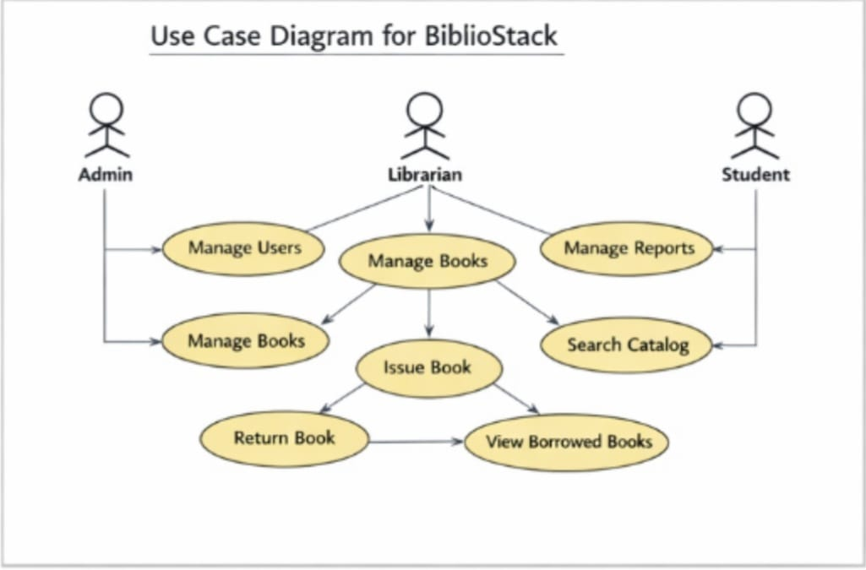Use Case Diagram: Shows interaction between Admin, Librarian, and Student.

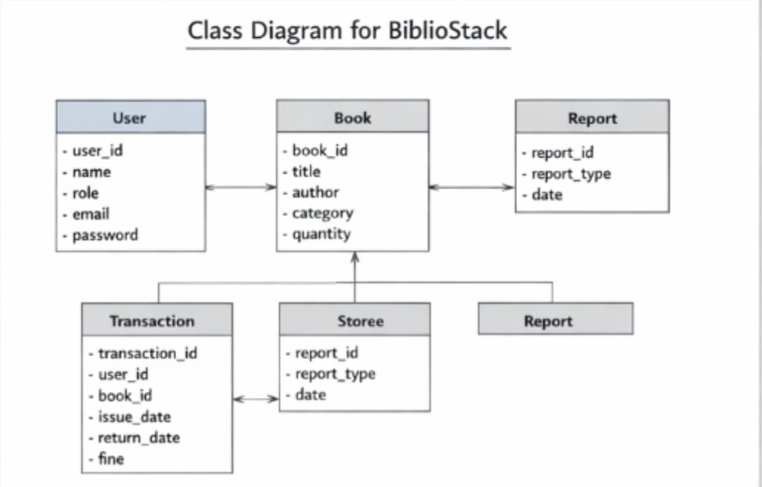
Class Diagram: Represents classes such as User, Book, Transaction, Report.

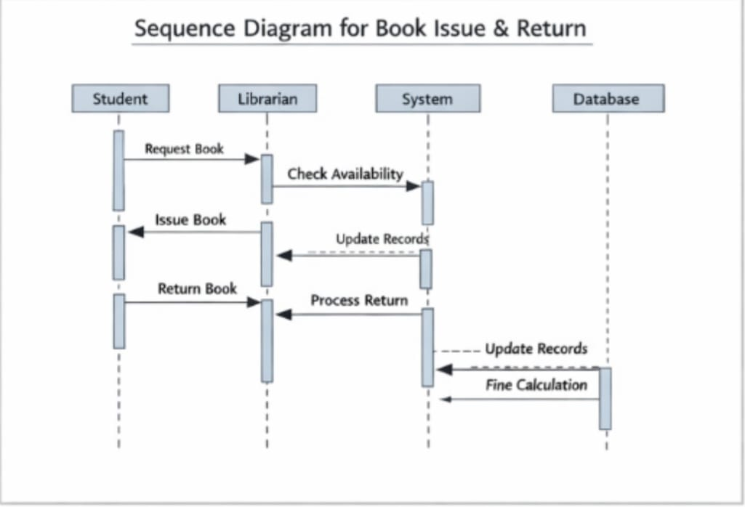Sequence Diagram: Describes book issue and return process.

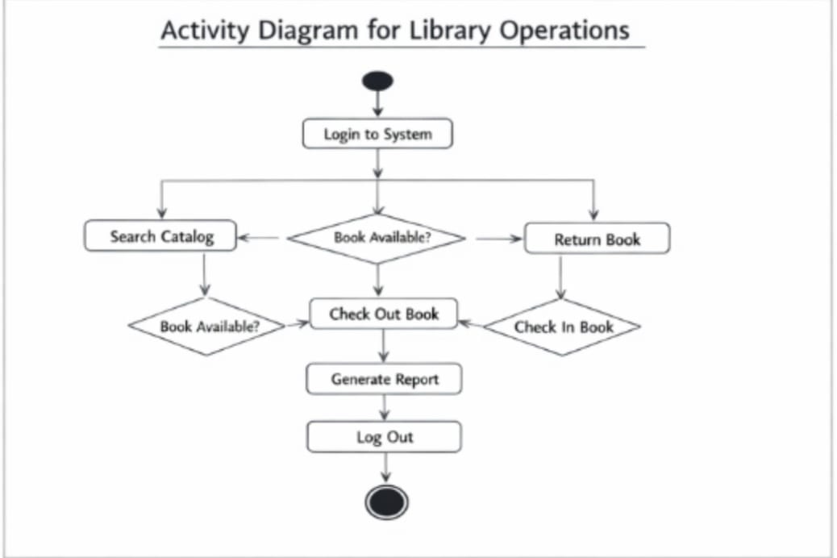
Activity Diagram: Illustrates workflow of library operations

5.3 Database Design

Main tables used:

- Users (user_id, name, role, email, password)
- Books (book_id, title, author, category, quantity)
- Transactions (transaction_id, user_id, book_id, issue_date, return_date, fine)

5.4 Screen Design

- Login Screen
- Admin Dashboard
- Book Management Screen
- Issue/Return Screen
- Student Dashboard

---

6. CONCLUSION

BiblioStack(E-BOOK) successfully automates library management processes and reduces manual effort. The system improves accuracy, saves time, and enhances user experience. It can be further enhanced by adding barcode scanning, mobile app support, and cloud integration.

---

7. LEARNING DURING PROJECT WORK

- Practical implementation of software engineering concepts
- Understanding of database design and normalization
- Experience with frontend and backend integration
- Team coordination and project documentation skills

8. BIBLIOGRAPHY

8.1 Online References

- [https://www.python.org](https://www.python.org)
- [https://flask.palletsprojects.com](https://flask.palletsprojects.com)
- [https://www.w3schools.com](https://www.w3schools.com)

8.2 Offline References

- Software Engineering – Pressman
- Databas

